

**SENTIMENT & EXPLORATORY DATA ANALYSIS OF TWEETS ON COVID-19 VACCINES**

INSY 5337 - WEB AND SOCIAL ANALYTICS PROJECT REPORT

**Group – 5**

Koushik Peddi

Mohit K Dundu

Satya Teja Kasula

Suchit S Kakirde

Contents

Section 1: INTRODUCTION 2

Section 2: DATA DESCRIPTION 2

Section 3: RESEARCH QUESTIONS 3

Section 4: METHODOLOGY 4

Section 4.1: Exploratory Data analysis and Data Pre-Processing 4

Section 4.2: Text Processing 6

Section 4.3: Tokenization and lemmatization 8

Section 4.4: Sentiment Analysis using VADER 9

Section 4.5: Text Blob 11

Section 5: RESULTS & DISCUSSIONS 13

Section 5.1: Subjectivity & Polarity 17

Section 5.2: Tree Mapping 19

Section 5.3: Interesting Statistics 21

Section 5.4: Inaccuracies of Text Analysis 22

Section 5.5: Sarcastic Tweets Analysis 23

Section 5.6: Impact of influencers on vaccines. 24

Section 6: CONCLUSION 27

Section 7: REFERENCES 27

# Section 1: INTRODUCTION

We discuss the public sentiment associated with the progression of COVID-19 vaccines using Twitter data, specifically Tweets for sentiment analysis, descriptive text analysis, and text data visualization, and show insights into the progression of fear-sentiment over time. We isolated a large number of individual tweets using a publicly available dataset and supplemented it with a slightly smaller dataset that we created by extracting new tweets using the Twitter API. The initial data came from tweets about the Pfizer/BioNTech vaccine, then there were tweets from Sinopharm, Sinovac, Moderna, Oxford/AstraZeneca, Covaxin, and Sputnik V vaccines added. The collection was twice a day in the beginning, until the Author approximated the new tweets quota, and then collection (for all vaccines) stabilized at once a day, during the morning hours (GMT). We analyzed sentiment of individual tweets using available sentiment computation libraries such as ‘TextBloB’ and ‘Vader’ and obtained sentiment polarity and subjectivity scores.

# Section 2: DATA DESCRIPTION

* Source 1: Kaggle

https://www.kaggle.com/dataseta/gpreda/all-covid19-vaccines-tweets?resource=download

Number of tweets used for Analysis using Kaggle Data set – 228207

Attributes:- Id, user_name, user_location, user_description, user_created, user_followers, user_friends, user_favourites, user_verified, date, text, hashtags, source, retweets, favorites, is_retweet.

* Source 2: Twitter Mining

To access Twitter API, the data is collected using the Tweepy Python package with a search term for each vaccine.

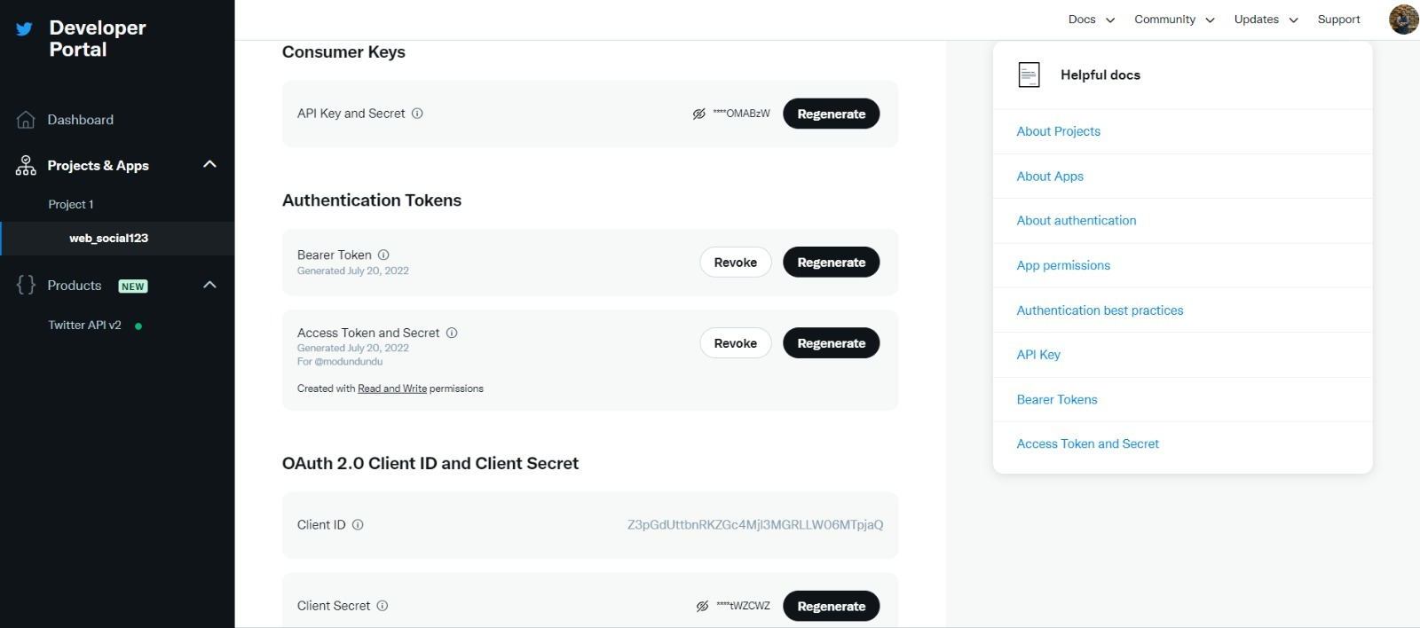

*Figure - 1*

Number of tweets used for Analysis using Twitter Mining – 4181

# Section 3: RESEARCH QUESTIONS

a. What is the aggregate sentiment per tweet and which sentiment is at peak?

b. Which countries are impacted the most by the tweets on vaccines? what are the root causes?

c. What is the effect of sarcastic tweets on sentiment analysis? How does our model tackle them? Are they correct as per our eye on glass monitoring?

d. What are the top three events which gave rise to increase per day tweet count?

# Section 4: METHODOLOGY

In this study, a methodology is proposed for conducting a systematic analysis of people's perspectives and perceptions of the Covid-19 worldwide vaccination. Five steps make up our strategy that we used.

* Exploratory Data analysis and Data Pre-Processing.
* Text Processing
* Tokenization & lemmatization
* Sentiment Analysis
* TextBlob vs VADER

### Section 4.1: Exploratory Data analysis and Data Pre-Processing

The initial stage of the data analysis process is called an exploratory data analysis (EDA). EDA is used by researchers and data analysts to comprehend and summarize a dataset's contents, usually with a specific question in mind, or to be prepared for more complex statistical modeling in later phases of data analysis. Data pre-processing is the process of converting raw data in a comprehensible data. Since we cannot work with raw data, it is a crucial step in data mining. Before using machine learning and data mining techniques, the quality of the data should be examined. We took the tweets and processed them to eliminate duplicate tweets from the overall number of tweets. Stop-words, these are the most common words in any language (such as articles, prepositions, pronouns, conjunctions, and so on) and do not add much information to the text. certain punctuation, some additional punctuation, and stray undesired symbols are removed from the text of the tweets during pre-processing in order to prevent their appearance while determining the word frequency distribution.

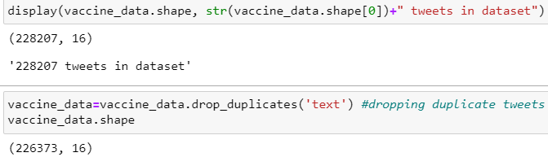

*Figure – 2*

Total tweets before and after removal of duplicates

**Data Timeline:**

We have converted the Date column to Date format using the Datetime function. Also, we have calculated the total number of days that the tweets were taken into consideration using Len function in python.

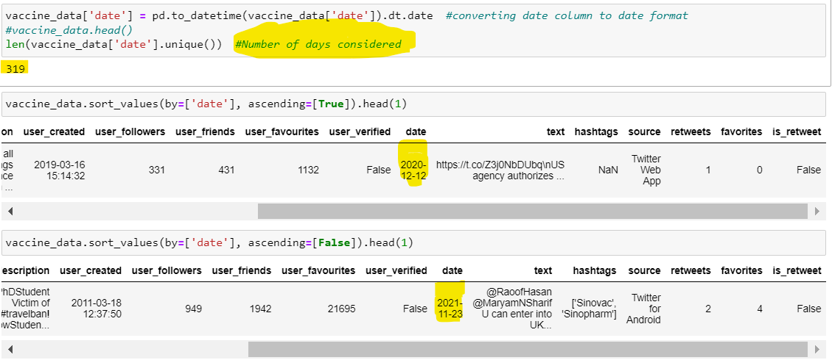

*Figure – 3*

Data Timeline

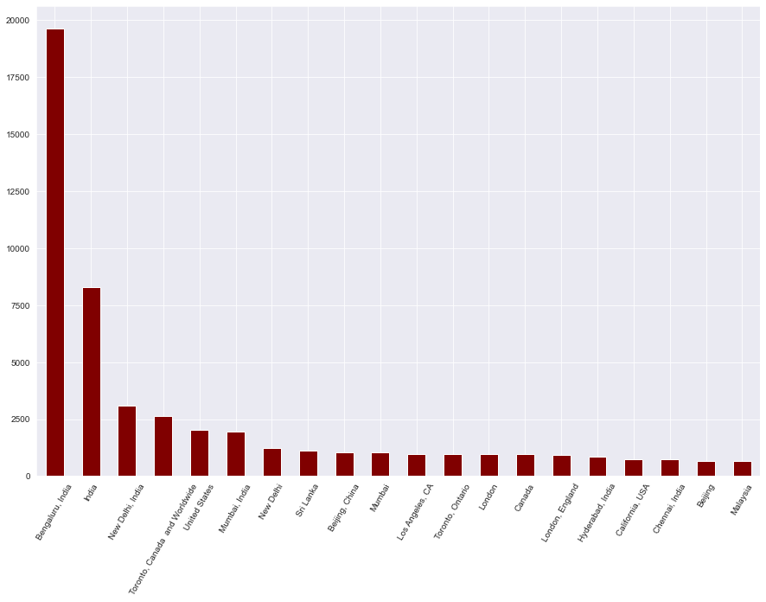

*Figure - 4*

Visualizing Tweet Count Vs Location

In comparison to other regions of Bangalore, and other locations of India, receive a lot more tweets. Malaysia posts the lowest quality tweets during the time period.

### Section 4.2: Text Processing

Text processing is the theory and practice of automating the creation or manipulation of electronic text in computing. Because a simple sentiment analysis would require a machine learning model to look for instances of positive or negative sentiment words, which could be provided to the model beforehand, this text processing is commonly used. This is text processing because the model is not understanding the words and is simply looking for words that it has been programmed to look for.

Text Processing here in our project involves 6 steps of processing. They are

* Converting into lower case
* Removing the URLs
* Removing the Punctuations.
* Single character and double space removal
* Removing the stop word
* Removing the emojis

*Figure –5*

6 steps of data pre processing

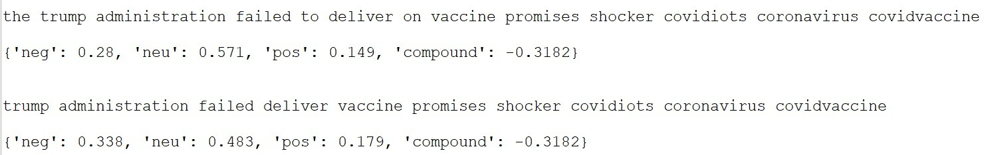

*Figure – 6*

Example of a tweet before and after pre-processing

### Section 4.3: Tokenization and lemmatization

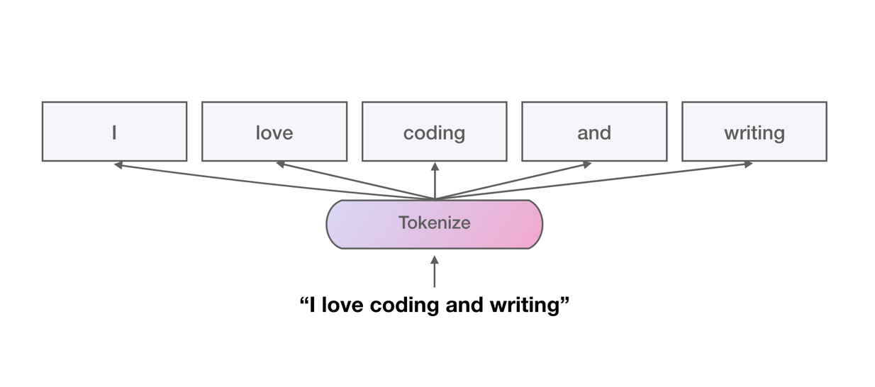

*Figure –7*

Example for Tokenization

One of the initial phases in any normal NLP assignment is to tokenize your text into individual words or tokens (process illustrated in the above picture), with the end result being used to produce so-called vocabularies that will be employed in the language model you aim to develop.

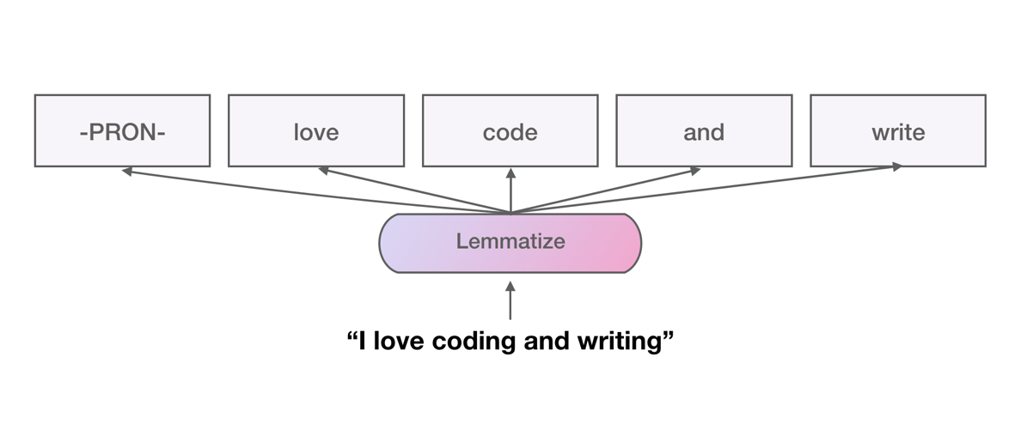

*Figure –8*

Example for Lemmatization

When we strive to reduce individual tokens from a sentence down to their most basic form, it is known as lemmatization. Having a vocabulary and using morphological analysis to get rid of inflectional endings are the processes that enable this. The lemma or the word's basic form is the result of the lemmatization procedure, as illustrated in the above picture. For instance, a lemmatization procedure reduces the inflections "am," "are," and "is" to the base form "be." Lemmatization is useful for normalizing text for NLP text classification tasks like sentiment classification.

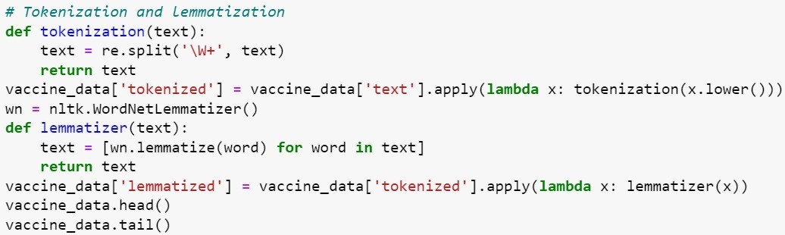

*Figure –9*

Code for Tokenization and Lemmatization

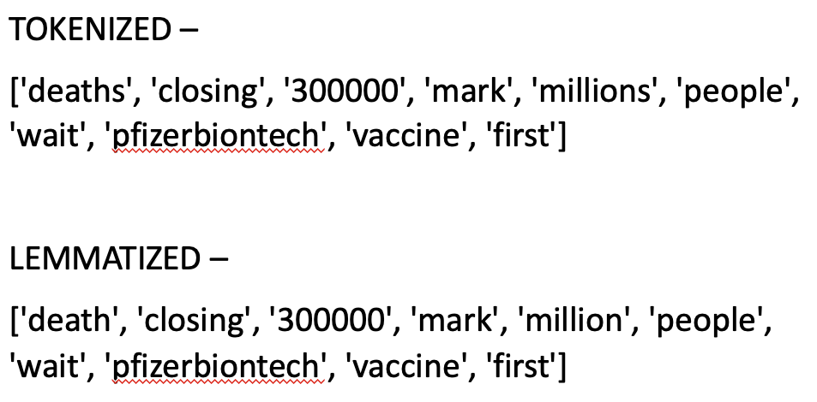

*Figure –10*

Tokenization vs Lemmatization

### Section 4.4: Sentiment Analysis using VADER

Sentiment analysis is a type of text analysis that detects polarity. Within the text, whether it is the entire document, a paragraph, a sentence, or a clause. Sentiment analysis seeks to quantify a speaker's or writer's attitude, sentiments, evaluations, and emotions using a computational treatment of subjectivity in a text**.** The Valence Aware Dictionary for Sentiment Reasoning (VADER) is a text sentiment analysis model that is sensitive to both polarity (positive/negative) and emotion subjectivity. It is included in the NLTK package and can be used on unlabeled text data directly. The sentimental analysis of VADER is based on a dictionary that maps lexical features to emotion intensities known as sentiment scores. A text's sentiment score can be calculated by adding the intensity of each word in the text. For example, the words 'love,' 'enjoy,' 'happy,' and 'like' all convey a positive sentiment. Furthermore, VADER understands the basic context of these words, such as "did not love" as a negative statement. It also recognizes the importance of capitalization and punctuation, such as "ENJOY." As we all know, the maximum length for a tweet is 140 characters.

VADER is the best model. Because VADER is more effective with short and long texts. Other models/libraries for sentiment analysis are available, but VADER is best suited for social media because it is smart enough to ignore grammatical formation of sentences, which is especially important in social media contexts. The main disadvantage of these models is that they cannot understand the context in which words are used. This will add a new column to the data set called 'Sentiment.'

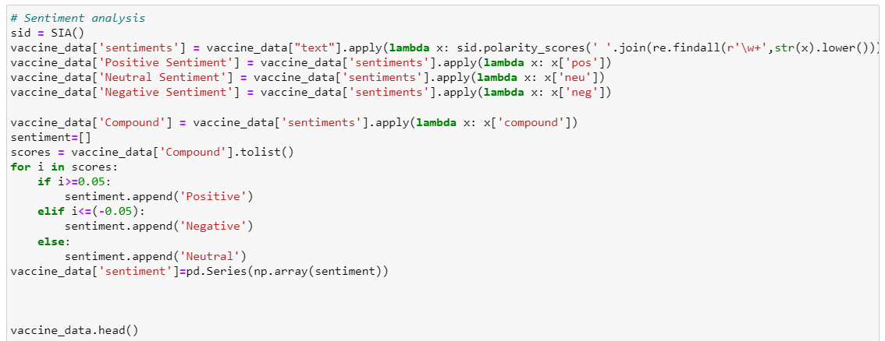

*Figure –11*

Code for Sentiment analysis

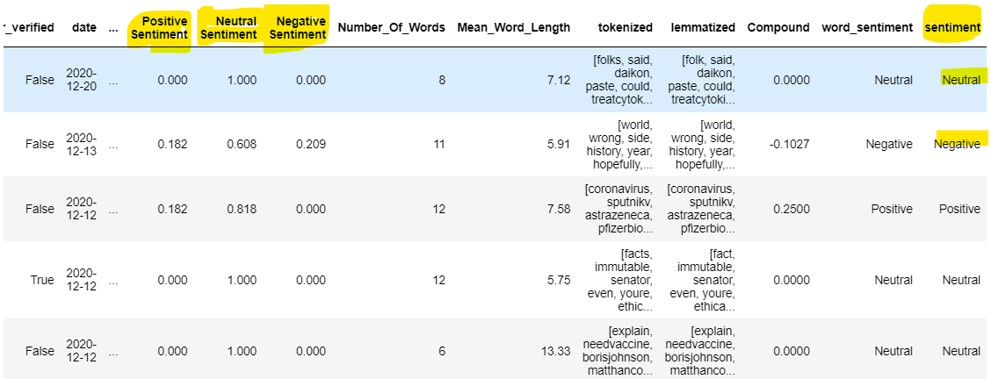

*Figure – 12*

Results of sentiment analysis

### Section 4.5: Text Blob

Text Blob is a Python library that allows you to process textual data. It provides a unified API for performing common natural language processing (NLP) tasks such as part of speech tagging, noun phrase extraction, sentiment analysis, classification, translation, and more.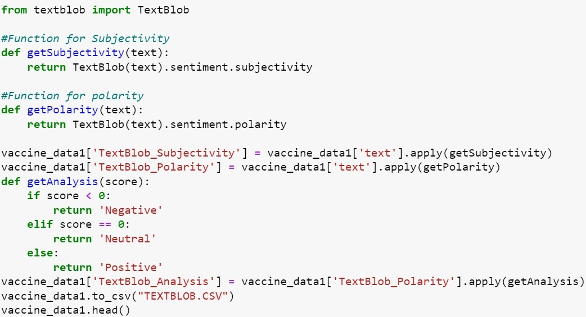

*Figure – 13*

Text Blob code

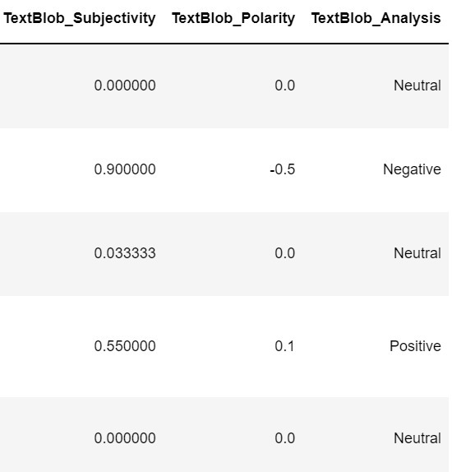

*Figure – 14*

Results of Text Blob

**Differences Between Text Blob and VADER**

There are two statements IMDB Review and Twitter Statement for which both Text Blob and VADER analysis have been done and their results are shown as follows.

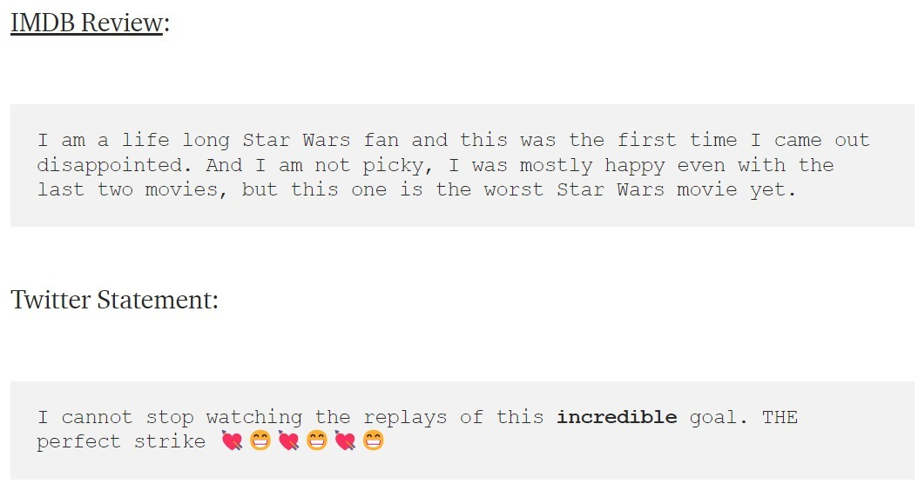

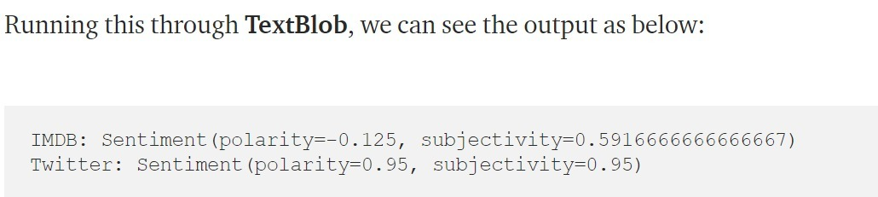

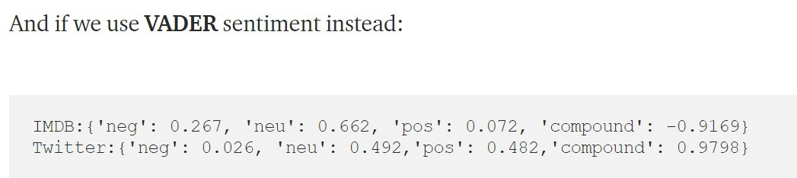

*Figure – 15*

Text Blob vs VADAR

# Section 5: RESULTS & DISCUSSIONS

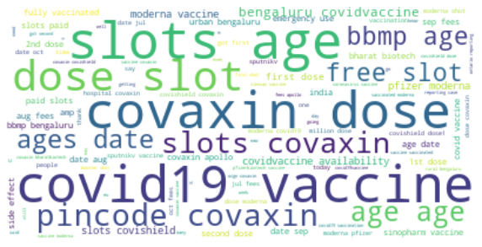 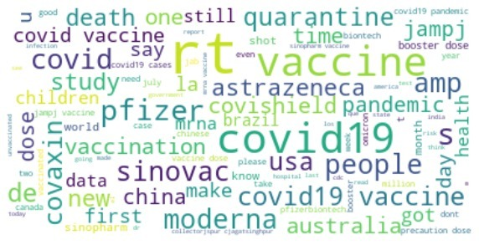

*Figure – 16 Figure – 17*

Word cloud for Most frequent words from Word cloud for Most frequent words from Kaggle data set. our own data set.

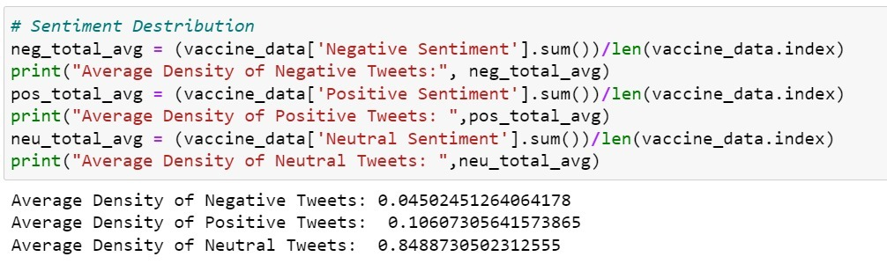

*Figure – 18*

The distribution of sentiments across tweets and average sentiment across tweets graphs were created using the Python code mentioned above.

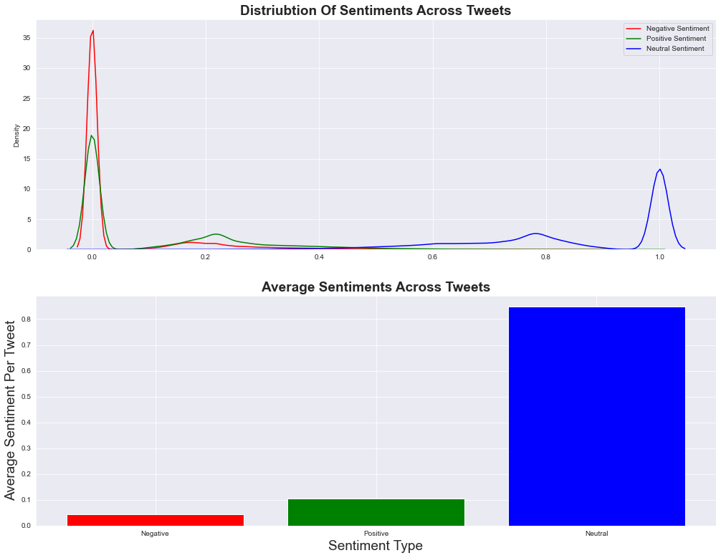

*Figure – 19*

The distribution of sentiments across tweets and average sentiment across tweets

Negative tweets have a high word density, with an average of 35 words per tweet. The average word count per tweet for positive tweets is about 18. With an average of just 14 words per tweet, neutral sentiment tweets have a lower word count than positive and negative ones. According to the "average sentiment across the tweets graph," neutral sentiment is present in the majority of tweets, while positive sentiment is far less common. The lowest number of tweets are those with negative sentiment.

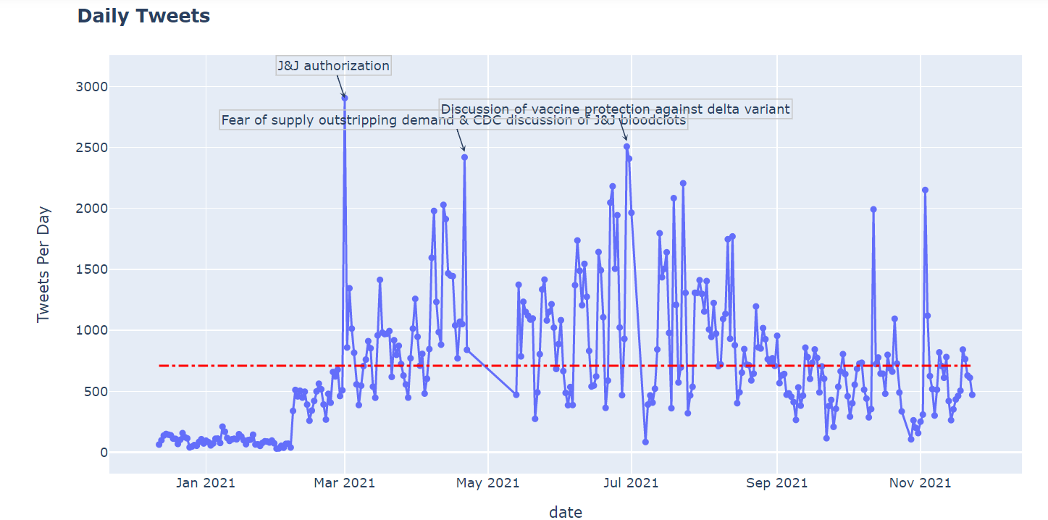

*Figure - 20*

Tweets per day

The number of tweets sent out each day is seen in the graph above. With 2800 tweets, the covid and vaccine-related tweets with various hashtags reached their high at the end of February and the beginning of March. The authorization of Jonson & Jonson's covid-19 vaccination approval is the cause. When we manually verified the data, we discovered that the company's workers posted tweets, and their followers retweeted them. In addition to that, there was active discussion surrounding the subject. The news of the blood clot problem with the Jonson & Jonson's vaccine coincided with the graph's second-highest peak. The debate about the COVID-19 delta variant was the third highest point.

### Section 5.1: Subjectivity & Polarity

The degree to which a person is personally involved in an object is referred to as subjectivity. Personal connections and individual experiences with that object are most important here, which may or may not differ from someone else's point of view. Text is said to be subjective when it is an explanatory article that must be analyzed in context.

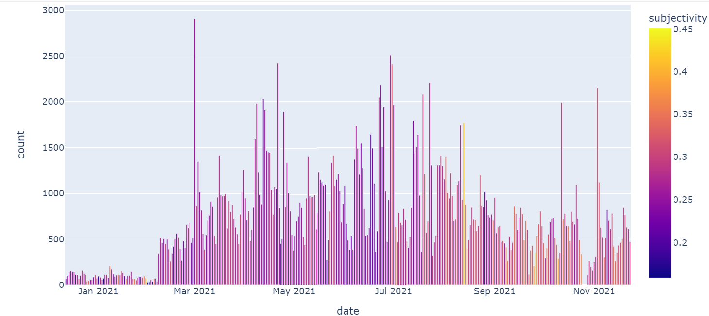

*Figure - 21*

Subjectivity Scale for daily tweets

Tweet volume and subjectivity are displayed in the stoph above. According to the subjectivity scale, the tweet might be classified as factual or subjective. The strength of a tweet's factualness is measured from 0.2 to 0.45. 0.45 is the lowest level. Few tweets are based on personal experience while the majority of tweets are factual in nature.

**Polarity** refers to the orientation of an emotion expressed in a sentence. It can be either positive, negative, or neutral. The term "polarity" describes how strong an opinion is. It could be favorable or unfavorable. Strongly favorable feelings or emotions, like admiration, trust, or love, will in fact have a certain orientation toward all other facets of an object's existence. The same is true with opposing polarities.



*Figure - 22*

Polarity scale for daily tweets

The opinion's (tweets) strength is represented in the graph above The scale, which ranges from 0.4 (the highest positivity) to -0.8 (the lowest positivity), reflects the sentiment of the tweets, which can be positive, neutral, or negative According to the graph, neutral to positive tweets predominate, with very few negative ones.

### Section 5.2: Tree Mapping

Tree mapping is a method for displaying hierarchical data in information visualization and computing that uses nested figures, typically rectangles. Treemaps display tree-structured data as nested rectangle assets. Each tree branch is assigned a rectangle, which is then tiled with smaller rectangles representing subbranches. The rectangle of a leaf node has an area proportional to a data dimension. The leaf nodes are frequently colored to represent a different dimension of the data. When the size and color dimensions are correlated in some way with the tree structure, patterns that would be difficult to spot in other ways, such as whether a particular color is particularly relevant, can often be easily seen. A second advantage of tree-maps is that they make efficient use of space by design. As a result, they can display thousands of items on the screen at the same time in a legible manner. The 50 most common words in positive tweets from the Kaggle dataset are listed below.

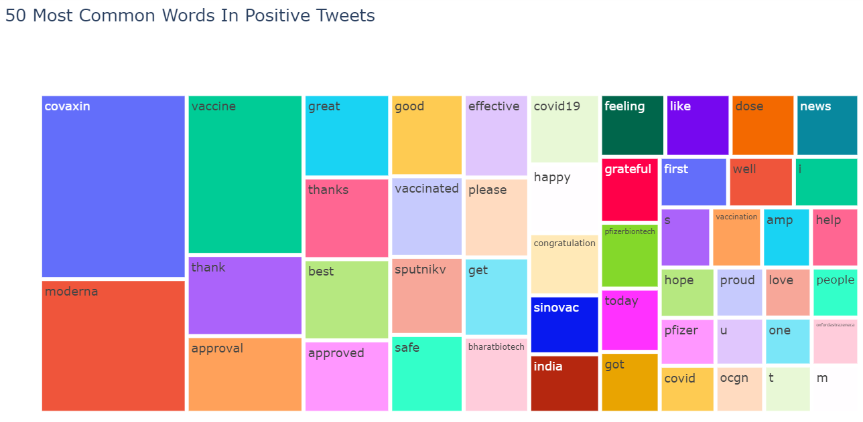

*Figure – 23*

Tree Mapping of the data set

From the above tree-map with 50 most common words in positive tweets the most commonly used words are Covaxin, Moderna, Vaccine etc. These are most commonly used in the positive tweets because these are the names of the vaccines that came into existence to overcome the deadly covid-19 disease. So, most of the people frequently used these words in their tweets. Also below are the most commonly used 50 negative tweets that are taken from the Kaggle dataset.

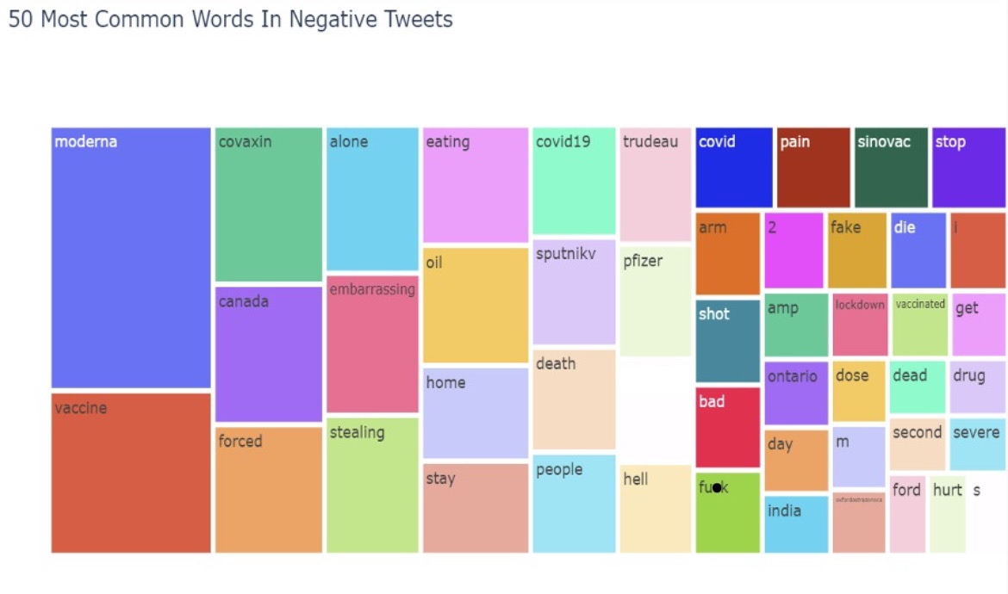

*Figure – 24*

Tree mapping of our own data set (for comparison)

From the above tree-map with 50 most common words in negative tweets the most commonly used words are Moderna, Vaccine, Canada etc. Moderna is used both in positive and negative tweets because it is having both positive and negative responses from the people. Mainly Moderna is used in both type of tweets because of its side effects after taking the vaccine.

### Section 5.3: Interesting Statistics

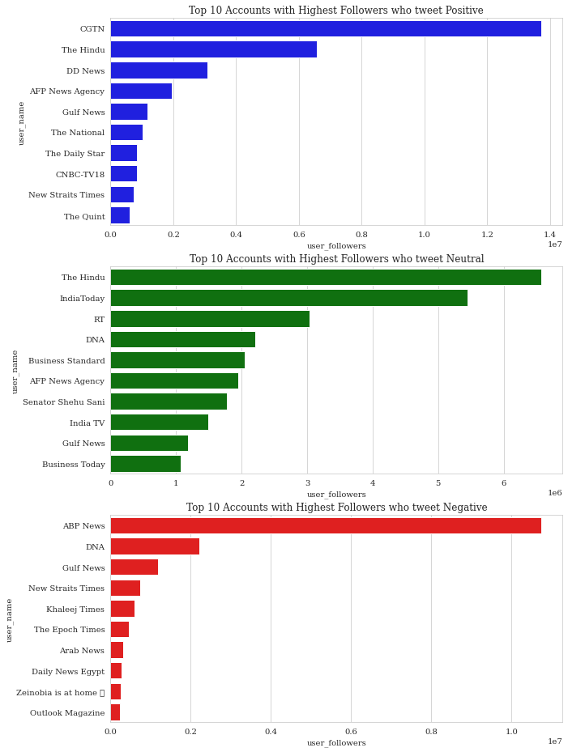

*Figure - 25*

From the above graph we can notice that Blue colour stats is for the top 10 accounts with highest followers who tweets positive, Green colour stats is for the top 10 accounts with highest followers who neutrally tweets and red colour stats is for the top 10 accounts with highest followers who tweets negative. In positive tweets graph CGTN, The Hindu has the highest followers and among the neutral tweets the Hindu and the India Today has the highest followers and finally among the negative tweets ABP news and DNA has the highest number of followers.

### Section 5.4: Inaccuracies of Text Analysis

It cannot analyse the sarcasm within the tweet. Even if the tweet is negative with the positive words containing, it is considered as a positive tweet.

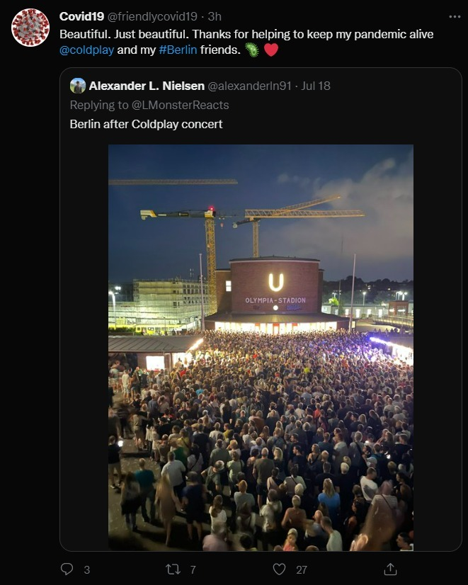

*Figure – 26*

Example of inaccurate results

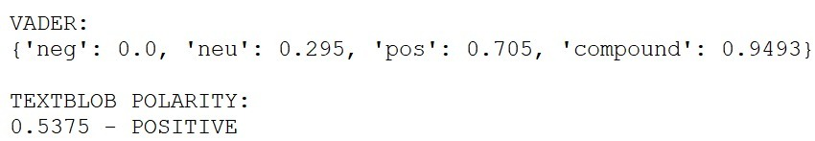

*Figure – 27*

Text Blob vs VADAR

### Section 5.5: Sarcastic Tweets Analysis

After manually searching our dataset for 'Sarcastic Tweets' that could cause a controversy during Text Analysis and analyzing the results, we can conclude that VADER is still superior to Text Blob. Below is the require analysis.

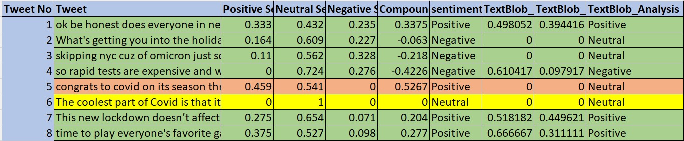

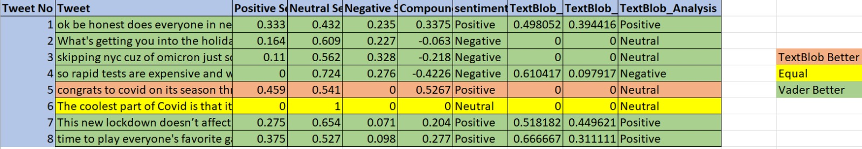

*Figure – 28*

**Examples for of sarcastic tweets**

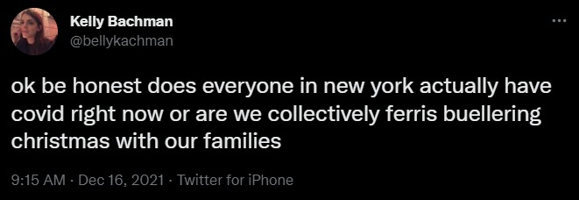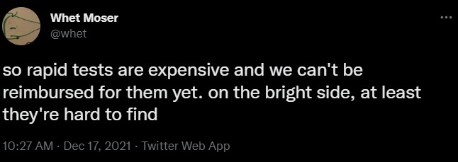

*Figure – 28*

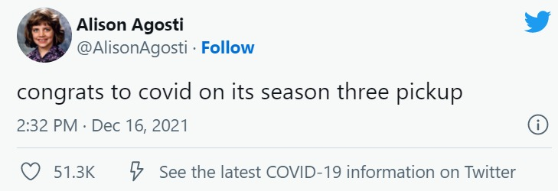

*Figure - 29*

### Section 5.6: Impact of influencers on vaccines.

You've probably heard the term "social media influencer." However, what exactly is a social media influencer?

They are simply people who have a large number of people under their influence. These people know how to brand themselves and attract a lot of attention. Twitter is the most popular social media influencer platform, followed by Instagram, Facebook, Snapchat, and YouTube.

While considering above mentioned scenarios we tried to peek into our trend of tweeter data base, and found that there are specific places where we can see that during certain periods the hatred towards the vaccine has been increased marginally. While looking further we found that the rise in negative sentiments is due to specific tweets by big influencers such as President of Brazil and anti-vaccines squad influencers from Canada.

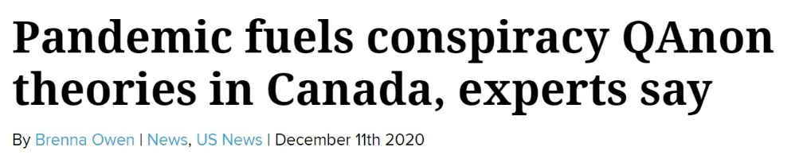

*Figure - 30*

While our further studies states that the Brazilian President's statement had an impact on the Twitter community (statement: People turning into Crocodiles after vaccine; DATED: 18th December 2020). We even considered some conspiracy theories from Canada that sparked anti-vaccine sentiment on Twitter around the same time. To better understand this scenario, we plotted nation wise sentiments before and after the dates of impact. And the results, particularly for Brazil and Canada, proved to be in our favor. Below are the before and after analysis of tweets.

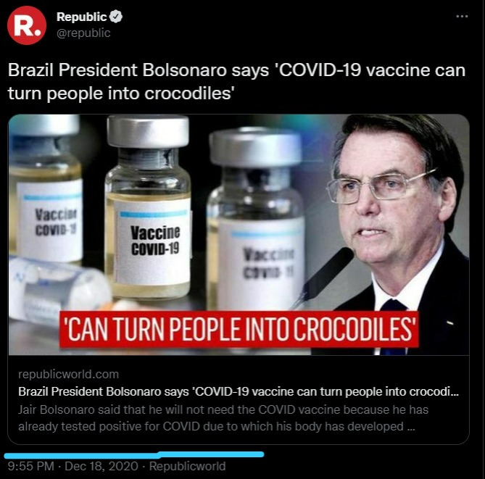

*Figure – 30*

Brazil President Tweet

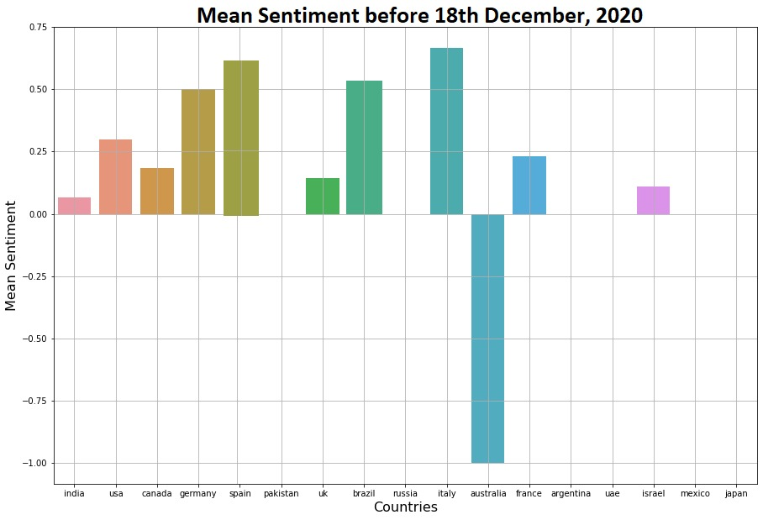

*Figure - 30*

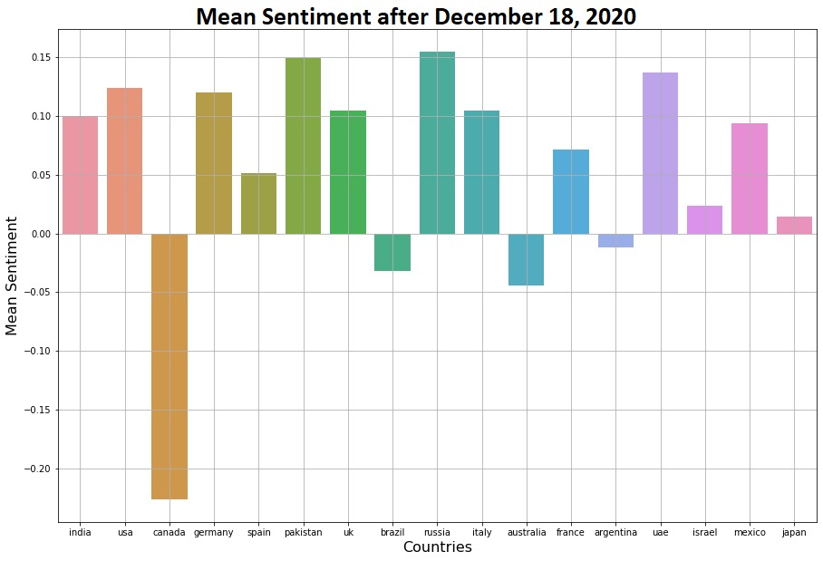

*Figure – 31*

# Section 6: CONCLUSION

The dissemination of information about Covid 19 vaccinations through social media has been crucial in raising awareness among many individuals about the need to get immunized in order to fight the deadly disease. Additionally, text analysis, a machine learning technique, is used to automatically mine or extract significant information from unstructured text data. It also aids in understanding human emotions by deleting emojis and other unnecessary letters or phrases from data or tweets. Our understanding leads us to the conclusion that, despite the accuracy of the match with human intelligence, there is still much room for development. In the current environment, influencers have the power to use social media to shape the opinions of the average person. In the future, corporations and small enterprises can also profit from such analysis and machine learning models to better understand consumer sentiment and expectations.

# Section 7: REFERENCES

* T Mustaqim et al 2020 J. Phys.: Conf. Ser. 1567 032024, Twitter text mining for sentiment analysis on government’s response to forest fires with vader lexicon polarity detection and k-nearest neighboralgorithm
* Astuti W T Muslim M A and Sugiharti E, 2019 Sci. J. Informatics 6(1) 95
* Safri Y F Arifudin R and Muslim M A, 2018 Sci. J. Informatics 5 (1) 18
* Ramanathan V and Meyyappan T, 2019 2019 4th MEC Int. Conf. Big Data Smart City pp 1–5.
* Thu P P, 2017 2017 IEEE/ACIS 16th Int. Conf. Comput. Inf. Sci. 2010 209
* Gabarron E Dorronzoro E Rivera-Romero O and Wynn R, 2019 J. Diabetes Sci. Technol. 13(3) 439
* Tyagi P and Tripathi R C, 2019 SSRN Electron. J. 5 1
* Terán L and Mancera J, 2019 Gov. Inf. Q. February 2018 p. 1
* Handani S W Intan D Saputra S and Mega R, 2019 J. Phys. Conf. Ser. 1196 1.
* Ravi A Khettry A R and Yelandur Sethumadhavachar S 2019 Advances in Computing and Data Sciences, 1, (Springer Singapore) p 403
* <https://www.qualtrics.com/experience-management/research/sentiment-analysis/>
* [https://medium.com/mlearning-ai/nlp-tokenization-stemming-lemmatization-and- part-of-speech-tagging-9088ac068768](https://medium.com/mlearning-ai/nlp-tokenization-stemming-lemmatization-and-%20part-of-speech-tagging-9088ac068768)
* <https://towardsdatascience.com/my-absolute-go-to-for-sentiment-analysis-textblob-3ac3a11d524>
* <https://towardsdatascience.com/sentimental-analysis-using-vader-a3415fef7664#:~:text=VADER%20(%20Valence%20Aware%20Dictionary%20for,directly%20to%20unlabeled%20text%20data>.
* <https://neptune.ai/blog/sentiment-analysis-python-textblob-vs-vader-vs-flair>
* <https://www.toptal.com/python/twitter-data-mining-using-python>
* <https://www.askpython.com/python/examples/extracting-tweets-using-twitter-api>
* <https://www.datarobot.com/blog/introduction-to-sentiment-analysis-what-is-sentiment->
* <https://www.researchgate.net/post/How_can_I_extract_all-time_Twitter_contents_using_keywords_without_Premium_or_Enterprise_API>
* <https://www.digitalocean.com/community/tutorials/how-to-authenticate-a-python-application-with-twitter-using-tweepy-on-ubuntu-14-04>
* <https://www.reddit.com/r/learnpython/comments/dm62qb/comment/f510h2z/>
* <https://www.crcresearch.org/crc-blog/sentiment-analysis-adding-qualitative-quantitative>